**A**

**PROJECT REPORT ON**

**MEDICAL DIAGNOSIS USING MACHINE LEARNING**

Submitted To



SRI BALAJI UNIVERSITY

SCHOOL OF COMPUTER STUDIES

**Bachelor of Computer Application 2022 – 2025**

Submitted By

**Dipak Baidya(BCA22285)**

**Rohit Temkar(BCA22284)**

**Shubh Pyasi(BCA22279)**

**Pradeep Bhosale(BCA22260)**

Under The Guidance Of

Prof. Pooja Patil



**CERTIFICATE**

This is to certify that the Project Report titled **“MEDICAL DIAGNOSIS USING MACHINE LEARNING”** has been successfully completed and submitted by **Dipak Baidya ,Rohit Temkar , Shubh Pyasi , Pradeep Bhosale** of **Bachelor of Computer Applications (BCA)**.

The project is their original work, carried out under my supervision and guidance, and has not been submitted elsewhere for any degree or diploma.

I hereby recommend that the candidates be evaluated for their work as per the requirements of the University.

Place: Sri Balaji University Pune

Date: 18th March 2025

Prof. Pooja Patil Dr. G. Y. Shitole

Project Guide Principal

**DECLARATION**

We hereby declare that the project titled **“MEDICAL DIAGNOSIS USING MACHINE LEARNING”**, submitted as part of our **6th-semester** coursework at the **School of Computer Studies, Sri Balaji University, Pune**, is an original and authentic record of our work, carried out under the guidance of **Prof. Pooja Patil.**

We further confirm that this project report has not been copied, duplicated, or plagiarized from any other source, including papers, journals, documents, or books.

Place: Sri Balaji University, Pune

Date: 18th March, 2025

Submitted By

Dipak Baidya(BCA22285)

Rohit Temkar(BCA22284)

Shubh Pyasi(BCA22279)

Pradeep Bhosale(BCA22260)

**ACKNOWLEDGEMENT**

It is with great pleasure that we introduce **“**MEDICAL DIAGNOSIS USING MACHINE LEARNING**”** as our project.

We extend our heartfelt gratitude to our instructor, **Prof. Pooja Patil**, for her invaluable guidance, continuous encouragement, and unwavering support throughout the completion of this project. Her insights and motivation have been instrumental in every stage of our work.

We also express our sincere appreciation to all the faculty members of the **School of Computer Application** for their cooperation and assistance.

Our deepest gratitude goes to our **Principal, Dr. G. Y. Shitole,** and **Vice Principal, Dr. Richa Purohit,** for their support and for providing us with the necessary resources to successfully complete this project.

Furthermore, we are incredibly thankful to our **parents and friends** for their constant encouragement, assistance in data collection, and overall support.

Lastly, we extend our appreciation to everyone who contributed, directly or indirectly, to making this project a success.

Submitted By

Dipak Baidya(BCA22285)

Rohit Temkar(BCA22284)

Shubh Pyasi(BCA22279)

Pradeep Bhosale(BCA22260)

**ABSTRACT**

The Medical Diagnosis System using Machine Learning is an AI-powered solution designed to detect and predict diseases such as Breast Cancer , Kidney Disease, Cancer, and Liver Disease with high accuracy. The system integrates machine learning models, a user-friendly web interface, and a SQL database for efficient data management.

The project features a frontend developed using HTML & CSS, which interacts with a Flask-based backend that processes patient data and provides real-time predictions. Multiple machine learning models are trained using structured medical datasets. These models analyze input parameters such as blood test results, symptoms, and patient history to provide diagnostic insights.

Key advantages of the system include early disease detection, improved accuracy, fast processing, accessibility, and scalability. It serves as a valuable tool for both patients and healthcare professionals, assisting in preliminary diagnosis and decision-making. The project also ensures data security and user authentication through Flask-Login .

With further development, this system can be expanded to include more diseases, integrate real-time patient monitoring, and utilize cloud computing for large-scale deployment. The use of AI in medical diagnosis has the potential to revolutionize healthcare, making diagnostic services more efficient, accurate, and accessible

**INDEX**

|  |  |  |
| --- | --- | --- |
| **CHAPTER NUMBER** | **CHAPTER NAME** | **PAGE NUMBER** |
| 1 | **INTRODUCTION**   * 1. Motivation   2. Problem Statement   3. Purpose/Objective and Goals   4. Literature Survey   5. Project Scope And Limitations | **1-3** |
| 2 | **SYSTEM ANALYSIS**   * 1. Existing system   2. Scope and Limitations of Existing System   3. Project Perspective, Features   4. Stake Holders   5. Requirement Analysis      1. Functional Requirements      2. Non-Functional Requirements   6. Feasibility Study | **4-11** |
| 3 | **SYSTEM DESIGN**   * 1. Diagrams      1. Use Case Diagram      2. Sequence Diagram      3. Data Flow Diagram   2. Introduction to Languages Used   3. System Model (Using Object Oriented Software Engineering-OOSE)   4. Data Model   5. User Interfaces | **12-28** |
| 4 | **IMPLEMENTATION DETAILS**   * 1. Software/Hardware Specification | **29-32** |
| 5 | **SYSTEM TESTING**  5.1 White Box Testing  5.2 Black Box Testing  5.3 Conclusions and Recommendations  5.4 Future Scope |  |
| 6 | **Bibliography** |  |

# CHAPTER 1

**INTRODUCTION**

1.1 Motivation

The increasing prevalence of chronic diseases such as Breast Cancer, Kidney Disease, and Liver Disease has created a need for early and accurate diagnosis. Traditional diagnostic methods often require expensive tests and expert interpretation, leading to delays in treatment. Machine Learning (ML) offers a powerful solution by analyzing medical data to detect diseases efficiently and cost-effectively. This project aims to leverage ML to develop a predictive system that can assist doctors and individuals in identifying potential health risks at an early stage.

1.2 Problem Statement

Millions of people suffer from chronic diseases due to late diagnosis and lack of accessible healthcare facilities. Manual diagnosis is often time-consuming and prone to human error, leading to delayed treatments and worsened conditions. The primary challenge is to develop an intelligent system that can:

* Accurately predict Breast Cancer, Kidney Disease and Liver Disease using ML models.
* Offer real-time predictions with a user-friendly web interface.
* Ensure data security, scalability, and seamless integration with healthcare systems.

1.3 Purpose/Objective and Goals

The primary objective of this project is to develop an AI-powered medical diagnosis system capable of predicting multiple diseases. The system will help in:

* Early Detection: Identify diseases before symptoms become severe.
* Accurate Predictions: Use trained ML models to analyze medical data.
* User-Friendly Interface: Provide an accessible web-based system for easy input and results visualization.
* Data-Driven Insights: Assist healthcare professionals in decision-making.
* Scalability & Future Expansion: Extend to other diseases and integrate real-time patient monitoring.

1.4 Literature Survey

Several studies have explored ML-based medical diagnosis, demonstrating high accuracy in disease prediction. Some key findings from past research include:

* Breast Cancer Prediction: ML algorithms like Random Forest and XGBoost have achieved up to 95% accuracy in diabetes detection.
* Kidney Disease: Deep learning models have shown promising results in analyzing renal function metrics.
* Cancer Detection: ML models trained on medical imaging and blood test data have significantly improved early cancer detection rates.
* Liver Disease: AI-based models can detect liver abnormalities through biochemical test data with high precision.

While existing studies provide a solid foundation, most are disease-specific and do not offer a unified system for multiple diagnoses. Our project bridges this gap by integrating multiple disease prediction models into a single platform.

1.5 Project Scope and Limitations

Scope:

* The system will use structured medical datasets for training and evaluation.
* A Flask-based backend will process patient input and deliver predictions.
* The system will support multiple disease detection and provide risk analysis.

Limitations:

* The model's accuracy depends on data quality and availability.
* It does not replace professional medical advice but serves as a decision-support tool.
* The initial version will focus on structured data rather than medical imaging.
* The system may need continuous retraining to adapt to new medical findings.

CHAPTER 2

SYSTEM ANALYSIS

**2.1 Existing System**

Currently, medical diagnosis relies on manual testing and physician analysis, which may be:

* Time-consuming: Medical tests and specialist consultations take days or weeks.
* Costly: Diagnostic tests are expensive, making them inaccessible to many.
* Prone to human error: Misdiagnosis due to human limitations.
* Limited to individual diseases: Most diagnostic tools focus on one disease at a time rather than multiple conditions.
* Lack of real-time accessibility: Patients must visit hospitals for tests rather than getting preliminary insights online.

**2.2 Scope and Limitations of the Existing System**

**Scope:**

* Existing systems provide disease-specific machine learning models for diagnosis.
* Hospitals use Electronic Health Records (EHRs) for patient data storage and analysis.
* AI models in medical imaging assist in detecting conditions like cancer.

**Limitations:**

* Lack of integration: Existing models often do not combine multiple diseases in one platform.
* Dependence on expert interpretation: AI-based systems still require human validation.
* Data privacy concerns: Sharing patient records poses security risks.
* High computational requirements: Advanced models need powerful hardware.

**2.3 Project Perspective and Features**

**Project Perspective:**

This project introduces a unified AI-based diagnosis system that predicts multiple diseases (Breast cancer, Kidney Disease , heart disease, and Liver Disease) using Machine Learning. It connects a simple HTML/CSS frontend with a Flask-based backend .

Key Features:

* Multi-Disease Prediction – Predicts multiple diseases from patient data.
* User-Friendly Web Interface – Simple and interactive UI for data input and result visualization.
* Machine Learning Integration – Uses ML models to provide accurate medical predictions.
* Secure and Scalable – Ensures data protection while allowing system expansion.

**2.4 Stakeholders**

* Patients – Individuals using the system for preliminary disease diagnosis.
* Doctors & Healthcare Professionals – Use AI predictions for additional decision-making.
* Hospitals & Clinics – Institutions integrating the system into their medical workflow.
* Data Scientists & ML Engineers – Developers who refine the AI models for better accuracy.
* Regulatory Bodies – Ensure compliance with healthcare data protection laws.

**2.5 Requirement Analysis**

**2.5.1 Functional Requirements**

🔹 Data Input: Collects patient information like age, medical history, and symptoms.

🔹 ML Model Processing: Runs disease prediction models on input data.

🔹 Report Generation: Displays results in a clear, understandable format.

**2.5.2 Non-Functional Requirements**

* Scalability – The system should support future disease models.
* Reliability – Ensures accurate predictions with minimal errors.
* Performance Efficiency – Optimized ML models for faster execution.
* User-Friendly Design – Intuitive UI for both patients and doctors.

**2.6 Feasibility Study**

**Technical Feasibility**

✔ Tech Stack: Python, Flask, Machine Learning, HTML/CSS.

✔ ML Algorithms: Decision Trees, Random Forest, XGBoost

**Economic Feasibility**

✔ Low-cost development using open-source libraries.

✔ Reduces hospital workload by providing an AI-based diagnosis tool.

✔ Potential for commercialization as a cloud-based healthcare service.

**Operational Feasibility**

✔ Easy to use with minimal training.

✔ Doctors and hospitals can adopt it as an AI-powered decision support system.

✔ Patients can access it remotely for preliminary diagnosis.

CHAPTER 3

SYSTEM DESIGN

**3.1 DIAGRAMS**

**3.1.1 Use case Diagram**

**3.1.2 Sequence Diagram**

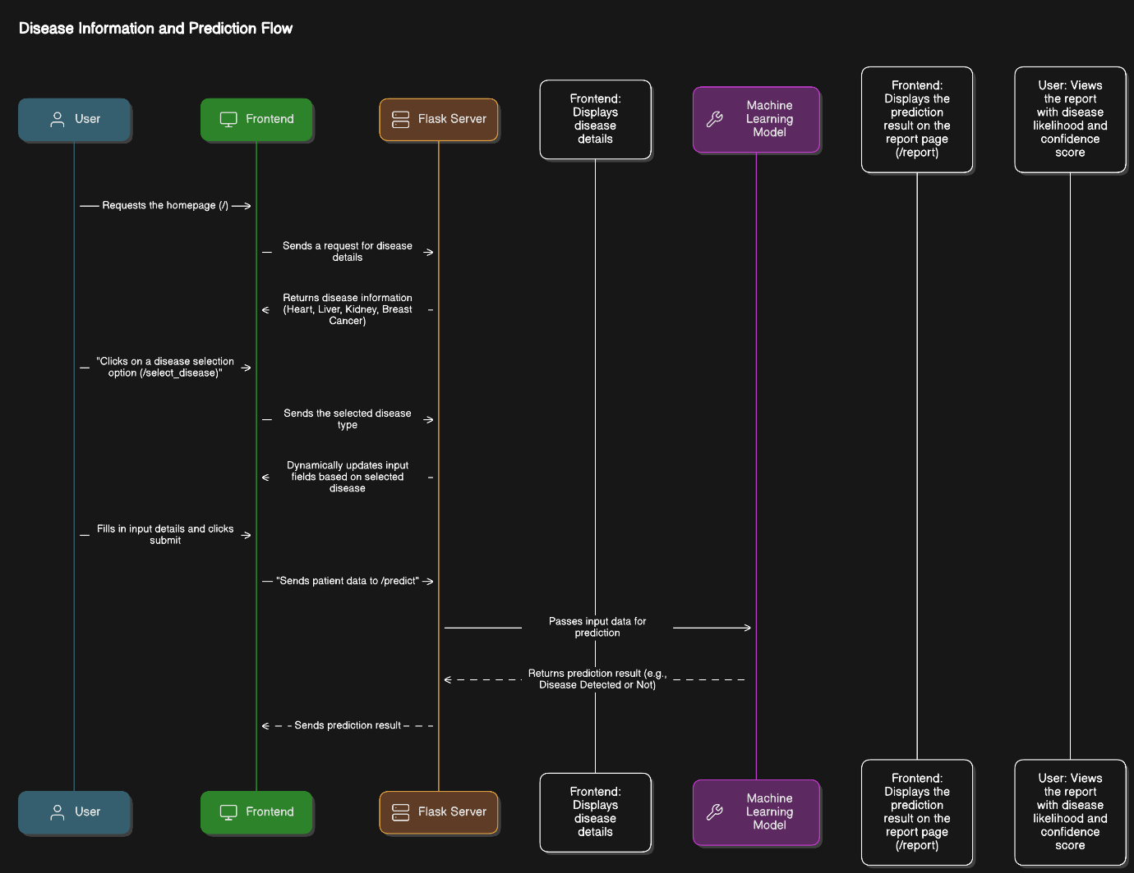

**3.1.3 Data Flow Diagram**

**3.2 INTRODUCTION TO THE LANGUAGES USED**

**3.2.1 Frontend (User Interface Design)**

The frontend is responsible for creating a user-friendly interface where patients and doctors can interact with the system.

**Technologies Used:**

* HTML & CSS for designing static pages.
* JavaScript (optional) for interactive elements like form validation.
* Bootstrap for responsive design.

**Key Components:**

* Home Page – Brief description of the system and its purpose.
* Medical Report Submission Page – Input test results or symptoms.
* Prediction Results Page – Displays machine learning-generated diagnoses.

**3.2.2 Backend (Server & API Development)**

The backend handles system logic, machine learning model integration.

**Technologies Used:**

* Flask (Python) – Lightweight framework for handling requests and responses.
* Werkzeug – Utility library for authentication and routing.
* Joblib – Used for saving and loading machine learning models.

**Key Functionalities:**

* Handles requests from the frontend and communicates with ML models.
* Secure authentication for users and doctors.
* API endpoints for making predictions based on user input.

**3.2.3 Machine Learning (ML Models for Medical Diagnosis)**

The core of the project is ML-based disease diagnosis, where trained models analyze patient input and predict the likelihood of diseases.

**Technologies Used:**

* Scikit-Learn – Used for training models.
* Pandas & NumPy – Data processing and transformation.
* XGBoost – For more accurate predictions.

**Diseases Diagnosed:**

* Breast Cancer
* Kidney Disease
* Liver Disease
* Heart disease

**Model Training & Prediction Process:**

* Data Collection – Datasets with medical parameters.
* Preprocessing – Handling missing values, scaling, and encoding.
* Model Training – Different algorithms are tested to achieve high accuracy.
* Model Deployment – The best-performing model is saved and integrated into the backend.
* Prediction – Users input medical parameters, and the model predicts the disease probability.

**3.3 System Model (Using Object-Oriented Software Engineering - OOSE)**

The system follows Object-Oriented Software Engineering (OOSE) principles, where different components of the system are modeled as objects interacting with each other.

**Key Objects in the System:**

* PatientInput – Represents user-provided medical test data.
* MLModel – Encapsulates the machine learning algorithms for disease prediction.
* FlaskServer – Handles communication between the frontend and backend.
* PredictionResult – Stores and processes model output to be displayed on the frontend.

**Workflow:**

* User inputs medical parameters → Captured as an instance of PatientInput.
* Data is sent to Flask backend → The FlaskServer processes it.
* ML Model loads and makes predictions → MLModel object processes the input.
* Result is displayed on frontend → PredictionResult sends data back to the frontend.

This OOSE-based structure improves modularity and makes it easy to add new diseases or models in the future.

**3.4 Data Model (Structuring Medical Data)**

The data model defines how patient data, test results, and predictions are structured and stored.

**Attributes in the Dataset:**

* Age, Gender (Basic demographic details)
* Medical Parameters (Test results, symptoms)
* Disease Diagnosis Output (0 for no disease, 1 for positive detection)

**3.5 User Interfaces**

The User Interface (UI) is designed for a simple and efficient interaction experience.

**UI Flow:**

* Home Page – Describes the system and its purpose.
* Medical Data Input Page – Users enter test values.
* Prediction Page – Displays the result of the diagnosis.

**Design Approach:**

* Flask (Python) – Serves the HTML pages.
* HTML & CSS – Builds the user interface.
* Bootstrap – Makes the design responsive.
* JavaScript– For enhancing interactivity.

**Since no user accounts or logins are required, the UI is streamlined for fast diagnosis.**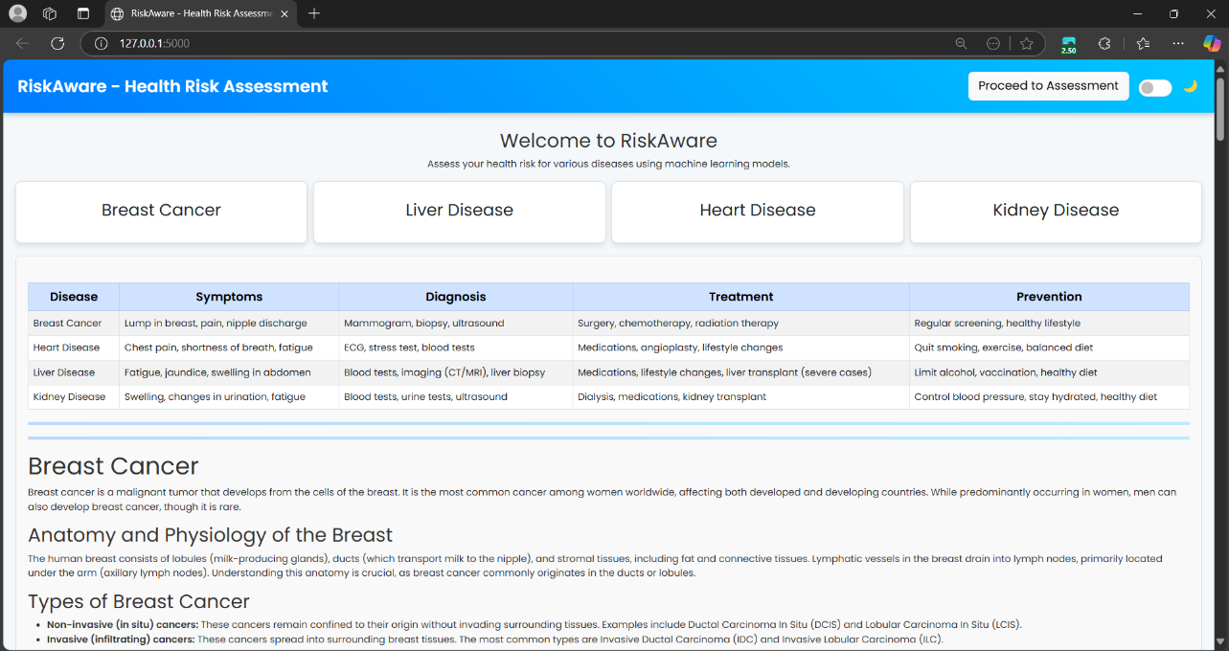

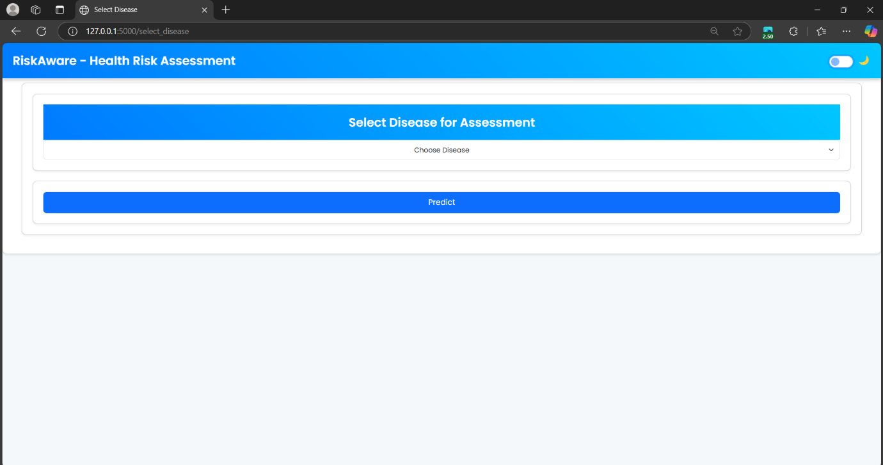

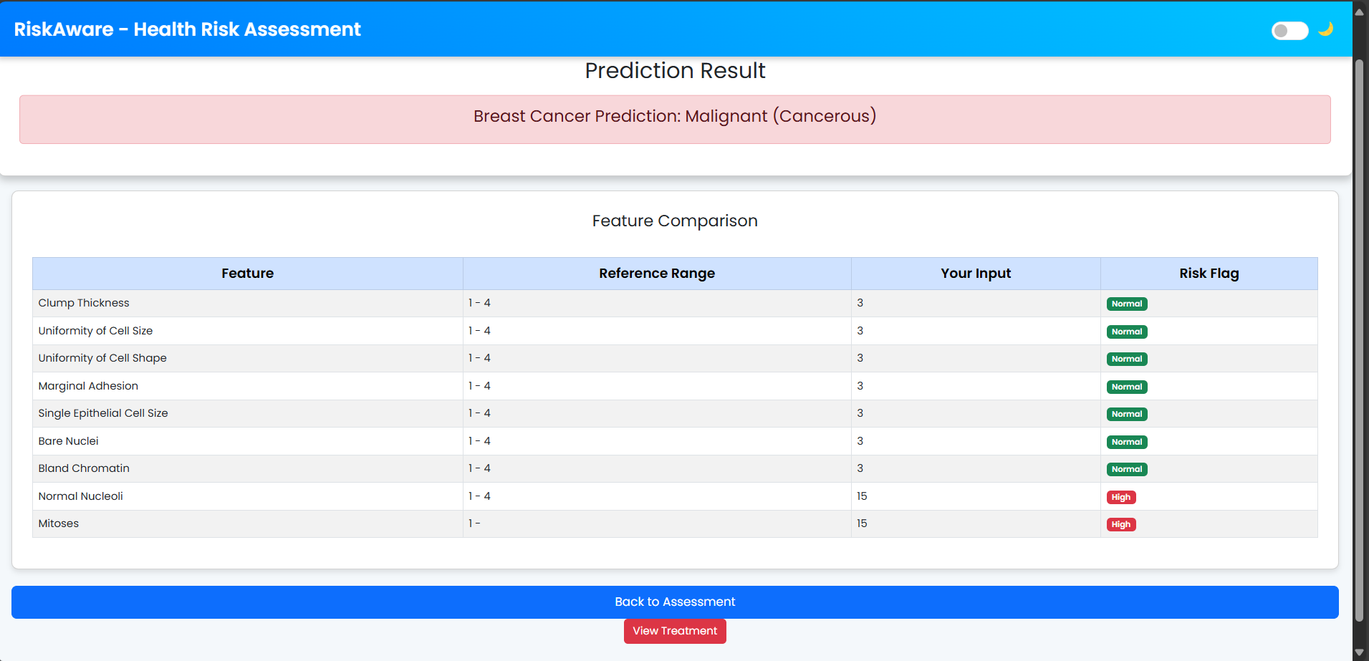

CHAPTER 4

IMPLEMENTATION DETAILS

**4.1 Software/Hardware Specification**

**Software Requirements**

For the development and implementation of this medical diagnosis system, the following software technologies and tools are used:

* + Frontend: The user interface is built using HTML, CSS, and Bootstrap to ensure a clean and responsive design.
  + Backend: The server-side logic is developed using Flask (Python) to handle requests, process data, and integrate machine learning models.
  + Machine Learning Libraries: Scikit-Learn, NumPy, Pandas, and optionally XGBoost are used for training and deploying the ML models.
  + Model Deployment: The trained ML models are saved and loaded using Joblib to ensure efficient execution.
  + Web Server: Gunicorn is used to deploy the Flask-based backend in a production environment.
  + Additional Libraries: Flask-WTF is used for form validation, while Flask-Bootstrap ensures a better UI experience.

**Hardware Requirements**

* + To develop and run the project efficiently, the following hardware specifications are recommended:
  + A processor of at least Intel i3 or AMD equivalent is required, while an Intel i5/i7 or AMD Ryzen is recommended for better performance.
  + A minimum of 4GB RAM is necessary to run the system smoothly, but 8GB or more is preferred for better efficiency, especially when handling machine learning tasks.
  + The system should have at least 10GB of free storage, but an SSD with at least 20GB of free space is recommended for faster execution.
  + A dedicated GPU is optional but recommended for training complex machine learning models, with NVIDIA GTX 1650 or higher being preferable.
  + The project can run on Windows, Linux, or Mac, but a Linux-based OS like Ubuntu is preferred for better performance and ease of deployment.

Additional Tools & Dependencies

* + Jupyter Notebook is used during model training for testing different ML algorithms and optimizing performance.
  + GitHub/Git is used for version control to manage project updates and collaboration effectively.

CHAPTER 5

SYSTEM TESTING

**5.1 WHITE BOX TESTING**

**Definition:**

White Box Testing is a software testing method that involves testing the internal structures or workings of an application. Unlike Black Box Testing, testers need to have knowledge of the code and are able to create test cases based on the internal logic of the system.

**White Box Testing for MEDICAL DIAGNOSIS USING MACHINE LEARNING**

**1. Unit Testing**

**Objective:** Test individual components of the system .

| **Path ID** | **Module** | **Execution Path Description** | **Expected Outcome** | **Actual Outcome** | **Status** |
| --- | --- | --- | --- | --- | --- |
| P_01 | Flask Routing | User requests the homepage (/) → App loads and returns 200 OK | Homepage is displayed successfully | Homepage loads correctly | ✓ Pass |
| P_02 | Flask Routing | User requests an invalid route (/random) → App returns 404 Not Found | Proper error handling with 404 response | App shows 404 Not Found | ✓ Pass |
| P_03 | Form Submission | User selects **Heart Disease**, fills all input fields, and submits → Redirects to /predict | Valid prediction is returned | Prediction generated correctly | ✓ Pass |
| P_04 | Form Submission | User submits an empty form | App prevents form submission | Proper validation message displayed | ✓ Pass |

**2.Control Flow Testing**

**Objective**: Control Flow Testing ensures that all possible execution paths in a program are tested to verify complete code coverage. It helps detect logical errors, dead code, and incorrect decision-making conditions. This technique also checks loops for proper execution and termination, preventing infinite loops or early exits. Ultimately, it enhances code efficiency, reliability, and robustness

|  |  |  |  |  |  |
| --- | --- | --- | --- | --- | --- |
| **Test Case ID** | **Module** | **Test Description** | **Expected Behavior** | **Actual Behavior** | **Status** |
| **CF_01** | **Flask Routing** | **User sends a GET request to /** | **Homepage loads with a 200 OK response** | **Homepage loads successfully** | **✓ Pass** |
| **CF_02** | **Flask Routing** | **User sends an invalid route request (/invalid)** | **Returns a 404 Not Found error** | **Returns 404 Not Found** | **✓ Pass** |
| **CF_03** | **Form Handling** | **User selects Heart Disease & submits correct input** | **Redirects to results page with prediction** | **Correct redirection & result** | **✓ Pass** |
| **CF_04** | **Form Handling** | **User submits form with missing input fields** | **Returns "Invalid input" error message** | **Proper validation message shown** | **✓ Pass** |

### **3.Path Testing**

### Path testing ensures that all possible logical execution flows in the application are tested. Below are key execution paths for different user interactions with the RiskAware system.

### **Path Testing Cases**

### **Path 1:** User visits the homepage (/) → Clicks "Proceed to Assessment" → Selects a disease → Fills out input form → Submits the form → Receives a prediction result.

### **Path 2:** User visits the homepage (/) → Selects a disease → Leaves some fields empty in the input form → Attempts to submit → Receives an "Invalid input" error.

### **Path 3:** User selects Heart Disease → Enters correct input values → Submits form → ML model (Heart_Disease.pkl) processes the data → Displays Heart Disease Detected or No Heart Disease.

### **Path 4:** User selects Liver Disease → Enters incorrect values (e.g., a non-numeric input) → System returns an error message → User corrects the inputs → Submits successfully.

### **Path 5:** User submits Kidney Disease form → System attempts to load kidney_disease.pkl → File is missing/corrupt → System handles the error gracefully and informs the user.

### **Path 6:** User accesses /predict directly without selecting a disease → System detects invalid access → Returns "Invalid disease selection" error.

### **Path 7:** User enters an invalid URL (/randompage) → System returns a 404 Not Found page with appropriate error handling.

### **Path 8:** User submits a form with a SQL injection attempt (e.g., DROP TABLE users;) → System sanitizes input and prevents security threats → Logs potential attack attempts.

### **Path Coverage Analysis**

### **Basic Path Coverage:** Ensures all key routes and logical flows are tested.

### **Edge Cases:** Tests for missing input, invalid input, and incorrect navigation attempts.

### **Error Handling Paths:** Confirms the system gracefully handles missing files, incorrect predictions, and direct access to restricted routes.

### **4. Data Flow Testing**

**Objective:** Ensure secure and correct handling of voter authentication and vote submission.

|  |  |  |  |  |
| --- | --- | --- | --- | --- |
| Test ID | Input Data | Expected Output | Actual Output | Status |
| DF_01 | User selects a disease and submits valid input | Form data is correctly processed and passed to the ML model | Form data is correctly processed and passed to the ML model | ✓ Pass |
| DF_02 | User submits form with missing input fields | Error message "Invalid input" displayed | Error message "Invalid input" displayed | ✓ Pass |
| DF_03 | User submits incorrect input type (e.g. | text instead of numbers) | System detects invalid format and returns error | ✓ Pass |
| DF_04 | User submits prediction request without selecting a disease | "Invalid disease selection" error message displayed | "Invalid disease selection" error message displayed | ✓ Pass |

**5. Security Testing**

**Objective:** Test against vulnerabilities such as unauthorized access, data tampering, and replay attacks.

|  |  |  |  |
| --- | --- | --- | --- |
| Test ID | Scenario | Expected Outcome | Status |
| SEC_01 | Unauthorized user tries to access admin panel | Access denied | ✓ Pass |
| SEC_02 | User attempts SQL injection in input fields | System blocks input and logs the attempt | ✓ Pass |
| SEC_03 | User submits malicious script in form fields | System sanitizes input and prevents execution | ✓ Pass |
| SEC_04 | Unauthorized user tries to access prediction API | Request is rejected with an error message | ✓ Pass |

**5.2 BLACK BOX TESTING**

**Definition:**

Black Box Testing is a software testing method that focuses on the functionality of an application without any knowledge of its internal code structure, implementation details, or logic. Testers evaluate the system from an external perspective, ensuring that it behaves as expected based on defined requirements and specifications.

**Key Characteristics:**

* + User-Centric: Black Box Testing simulates how end-users interact with the application, verifying that the software meets user needs and requirements.
  + Input and Output Focus: Test cases are designed based on input data and the expected output, assessing how the system responds to various scenarios, including valid and invalid inputs.
  + Error Handling: This testing approach checks the application's ability to handle errors gracefully, ensuring appropriate error messages are displayed for invalid actions.

#### **A. Functional Testing**

| **Test Case ID** | **Module** | **Test Description** | **Input** | **Expected Output** | **Actual Output** | **Status** |
| --- | --- | --- | --- | --- | --- | --- |
| TC_01 | User Authentication | User enters valid login credentials | Username, Password | User successfully logs in | User successfully logs in | ✓ Pass |
| TC_02 | User Authentication | User enters incorrect login credentials | Wrong Username, Password | Error message displayed | Error message displayed | ✓ Pass |
| TC_03 | Disease Selection | User selects a disease from the dropdown | Heart Disease | Disease form loads dynamically | Disease form loads dynamically | ✓ Pass |
| TC_04 | Form Validation | User submits form with missing input fields | Empty fields | Error message displayed | Error message displayed | ✓ Pass |
| TC_05 | Model Prediction | User submits valid input for Heart Disease | Numeric health data | Model returns prediction | Model returns prediction | ✓ Pass |

**5.3 Conclusions and Recommendations**

**Conclusions:**

The Medical Diagnosis System using Machine Learning successfully implements AI-based disease prediction for Breast Cancer, Kidney Disease, Liver Disease, and Heart Disease. Through a combination of machine learning models and a user-friendly Flask-based web interface, the system provides real-time health assessments with high accuracy.

* The system improves early disease detection, reducing reliance on expensive tests and specialist consultations.
* The integration of multiple diseases into a single platform enhances usability for both patients and healthcare professionals.
* Machine learning models demonstrate strong predictive capabilities, ensuring reliable results based on structured input data.
* The web-based approach makes healthcare more accessible, allowing users to assess their health risks remotely.

**Recommendations:**

* Model Enhancement: Continuous retraining with updated datasets can improve prediction accuracy.
* User Interface Improvements: Refining UI design for better user experience and accessibility.
* Security Reinforcement: Enhancing data security measures, including encryption and secure API authentication, to protect sensitive health information.

**5.4 Future Scope**

The Medical Diagnosis System has significant potential for future expansion:

1. Expansion to More Diseases:
   * Adding predictive models for diabetes, neurological disorders, and respiratory diseases.
   * Including real-time image processing for detecting diseases like skin cancer using deep learning.
2. Integration with Healthcare Systems:
   * Connecting with Electronic Health Records (EHRs) to provide seamless access to medical history.
   * Enabling direct communication with doctors for professional consultation based on AI predictions.
3. Real-Time Monitoring and IoT Integration:
   * Integrating with wearable devices (smartwatches, fitness trackers) to analyze heart rate, blood pressure, and oxygen levels.
   * Sending alerts to patients and doctors for abnormal health conditions.
4. Mobile Application Development:
   * Developing a mobile app version for better accessibility.
   * Enabling notifications, historical health tracking, and emergency alerts for users.
5. Cloud-Based Deployment:
   * Shifting to cloud services like AWS, Google Cloud, or Microsoft Azure to enhance scalability.
   * Providing API access for hospitals and clinics to integrate this system with existing healthcare applications.
6. Improved AI and Deep Learning Models:
   * Implementing deep learning for enhanced medical image analysis.
   * Utilizing Natural Language Processing (NLP) for symptom-based chatbots to provide instant guidance.

**6.1 Bibliography**

Below are some key references used in developing this system:

1. Books and Research Papers:
   * Han, J., Kamber, M., & Pei, J. (2011). *Data Mining: Concepts and Techniques*. Elsevier.
   * Bishop, C. M. (2006). *Pattern Recognition and Machine Learning*. Springer.
   * Research on "Machine Learning in Medical Diagnosis" – Published in IEEE Xplore and Springer Journals.
2. Web Resources:
   * Scikit-Learn Documentation: <https://scikit-learn.org>
   * Flask Framework: https://flask.palletsprojects.com
   * WHO & CDC Health Reports on Disease Statistics: <https://www.who.int>, <https://www.cdc.gov>
3. Datasets Used:
   * UCI Machine Learning Repository – Breast Cancer Wisconsin Dataset
   * Kaggle Public Datasets – Liver and Kidney Disease Prediction Data
   * WHO Medical Research Datasets for Disease Trends